**Business to Business(B2B) Topics**

**Account Management in B2B**

**B2B Account management:**

* B2B account management in Magento 2 is how businesses handle their relationships with other businesses using the Magento 2 platform.
* It involves tools and features to manage these business accounts effectively.

**Purpose:**

* The purpose of B2B account management in Magento 2 is to make it easier for businesses to sell to other businesses.
* It helps build good relationships with business customers and makes the buying process smoother.

**Usage:**

* Businesses use B2B account management in Magento 2 to organize their business customers, set up special prices for them, handle requests for quotes, and make sure orders are approved before they're processed.
* It also provides a dashboard to manage everything in one place.

**Benefits:**

* The benefits of B2B account management in Magento 2 include better understanding of business customers, offering them fair prices, making quoting and order approvals quicker, having all account information in one spot, and building long-term relationships.

**Disadvantages:**

* there are some downsides to B2B account management in Magento 2. It can be tricky to set up and manage pricing and approvals, especially for businesses with many business customers.
* Connecting Magento 2 with other systems can be difficult, and it takes time and expertise to use these features well, which might be hard for smaller businesses.

**Account Management in B2B Importantance:**

Add numerous company accounts to your store as an admin

Businesses can create and manage sub-account from the frontend

Easily manage multiple company accounts in one place

Grow sales with custom marketing and pricing based on the company membership

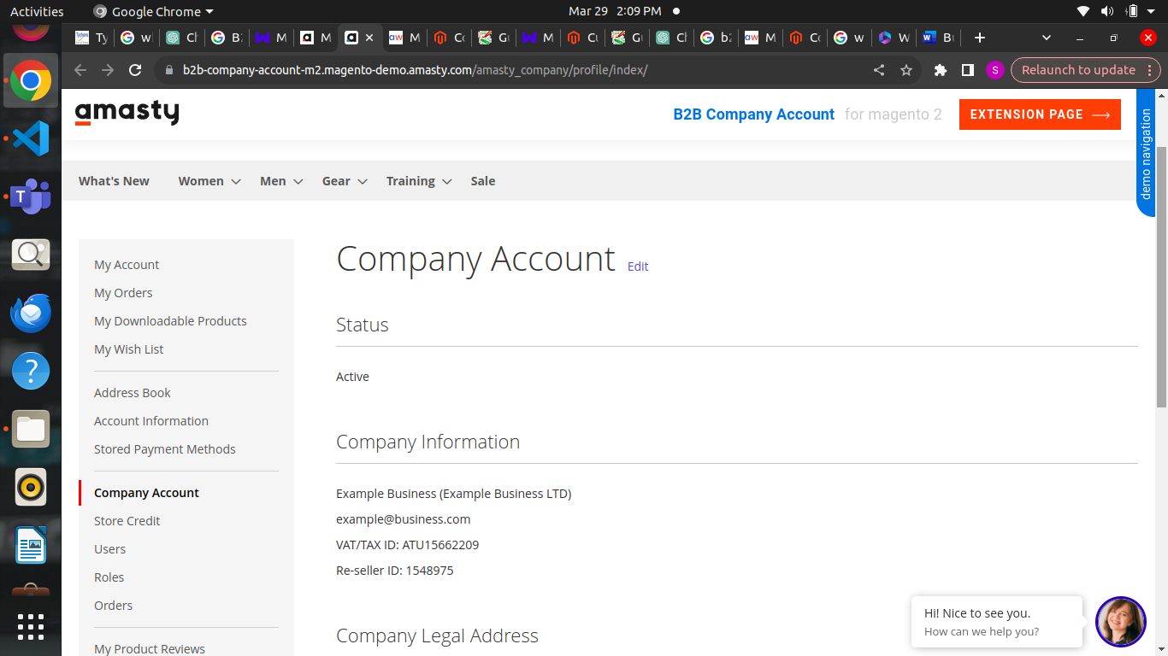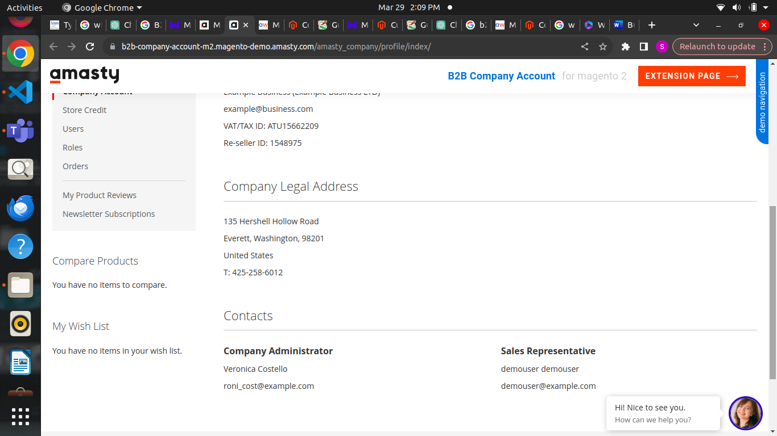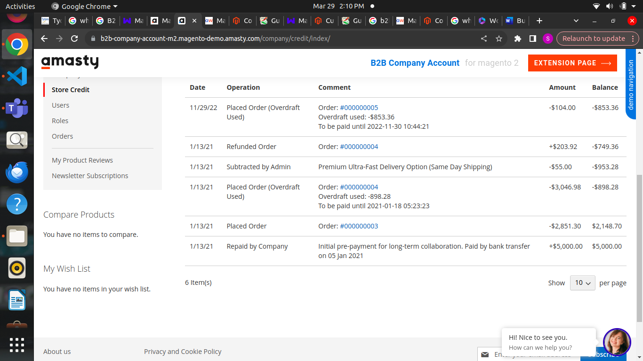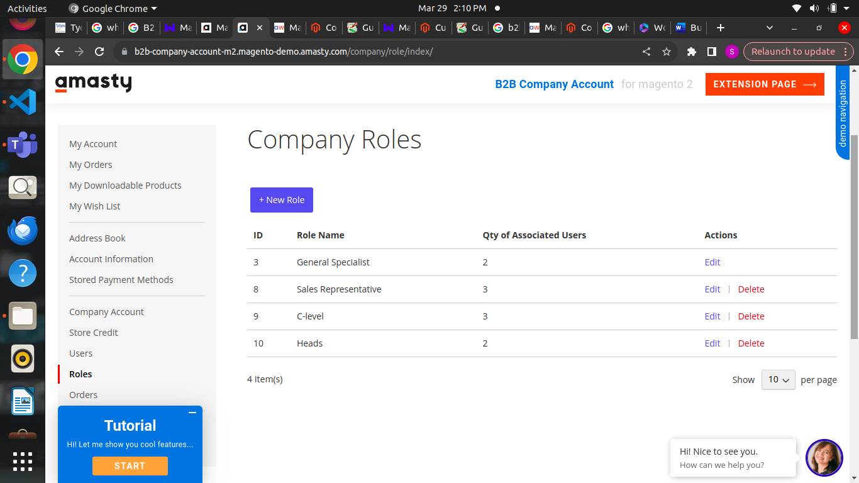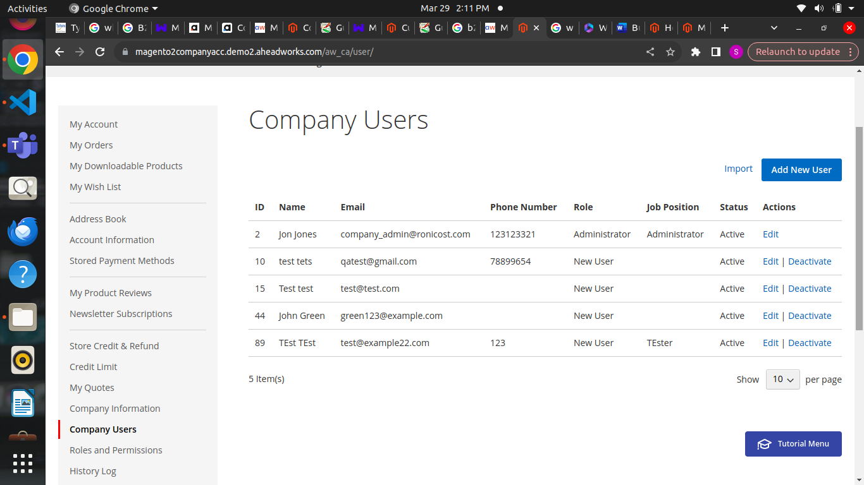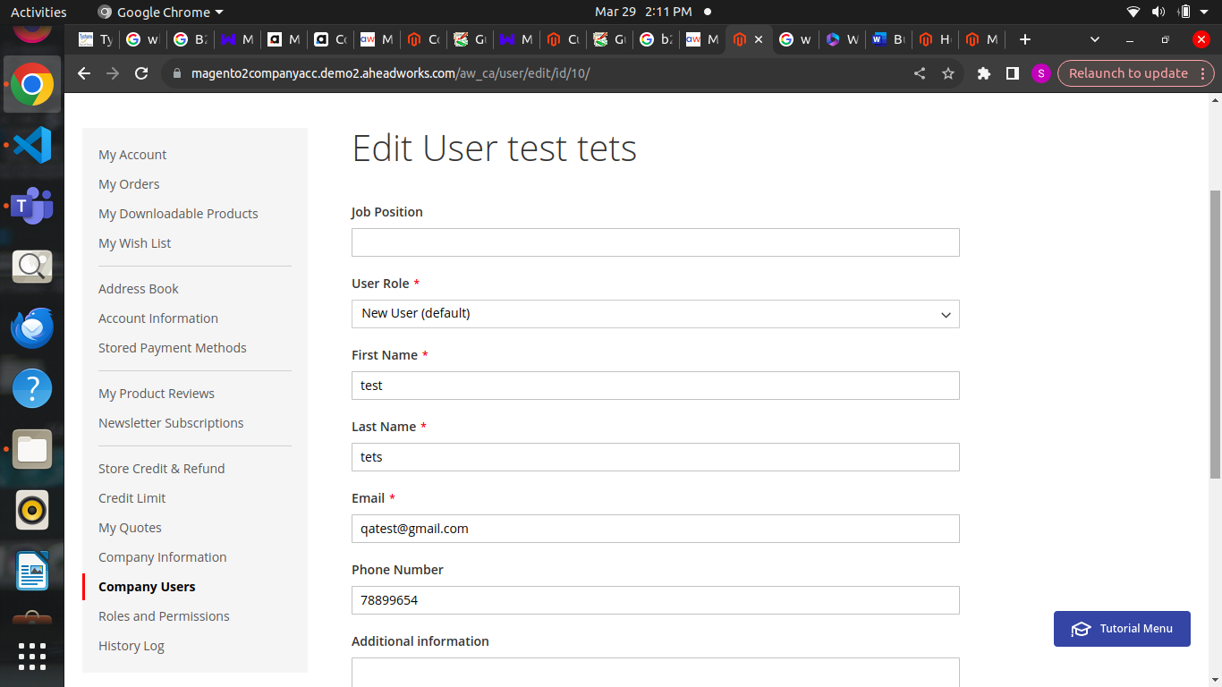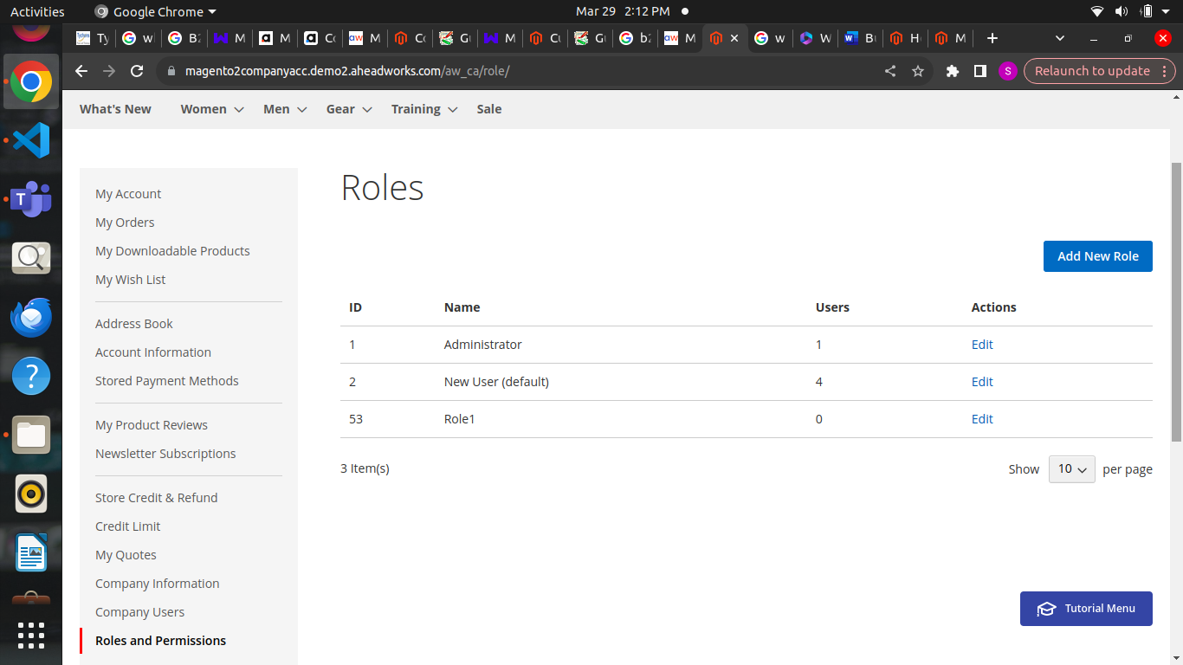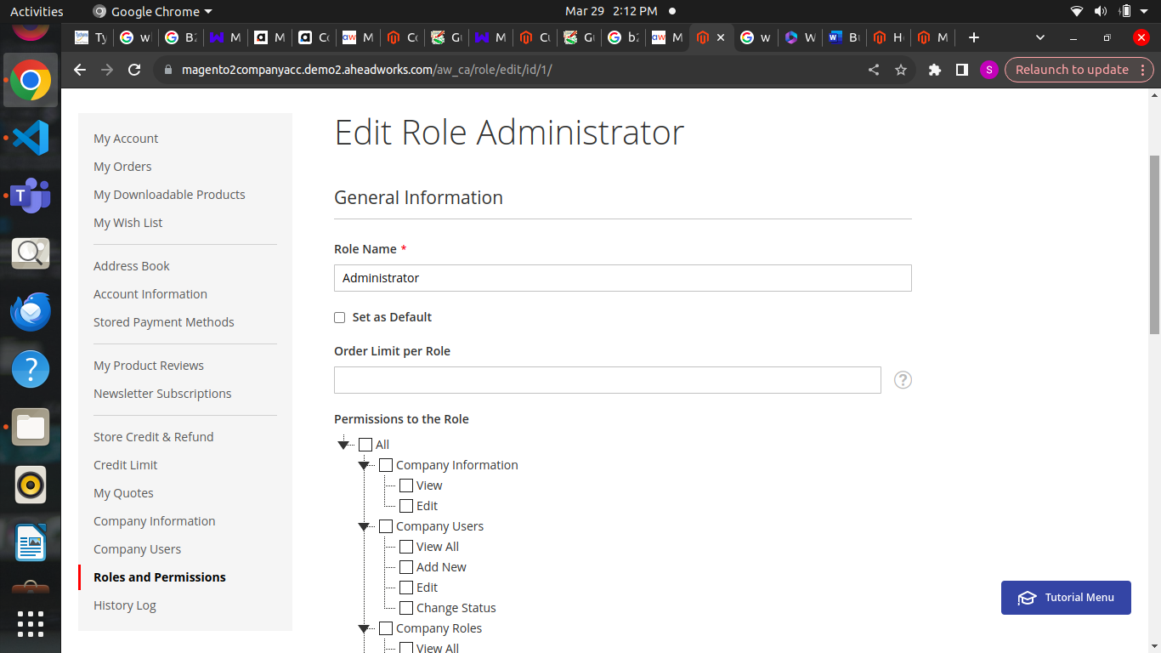

We can be able to create multiple businesses accounts

We can be able to customer users and edit users and we can be able to edit roles and permissions also

**Custom Pricing and Quoting in B2b Magento 2**

**Custom Pricing and Quoting**

* B2B custom pricing and quoting in Magento 2 are features that allow businesses to set special prices for their B2B customers and create quotes for products or services based on their specific needs.

**Purpose**

* The purpose of B2B custom pricing and quoting in Magento 2 is to make it easier for businesses to offer personalized pricing to their B2B customers.
* It helps build stronger relationships and encourages more sales by customize prices to individual needs.

**Usage**

* Businesses use B2B custom pricing and quoting in Magento 2 to set different prices for different B2B customers, based on factors like order quantity or customer loyalty.
* We can also create custom quotes for B2B clients, which may include special discounts

**Benefits**

* The benefits of B2B custom pricing and quoting in Magento 2 include increased customer satisfaction, better negotiation opportunities, improved sales by offering competitive prices, and the ability to attract and retain B2B clients with personalized pricing.

**Disadvantages:**

* It can be time consuming to manage different pricing especially for businesses with many b2b customers

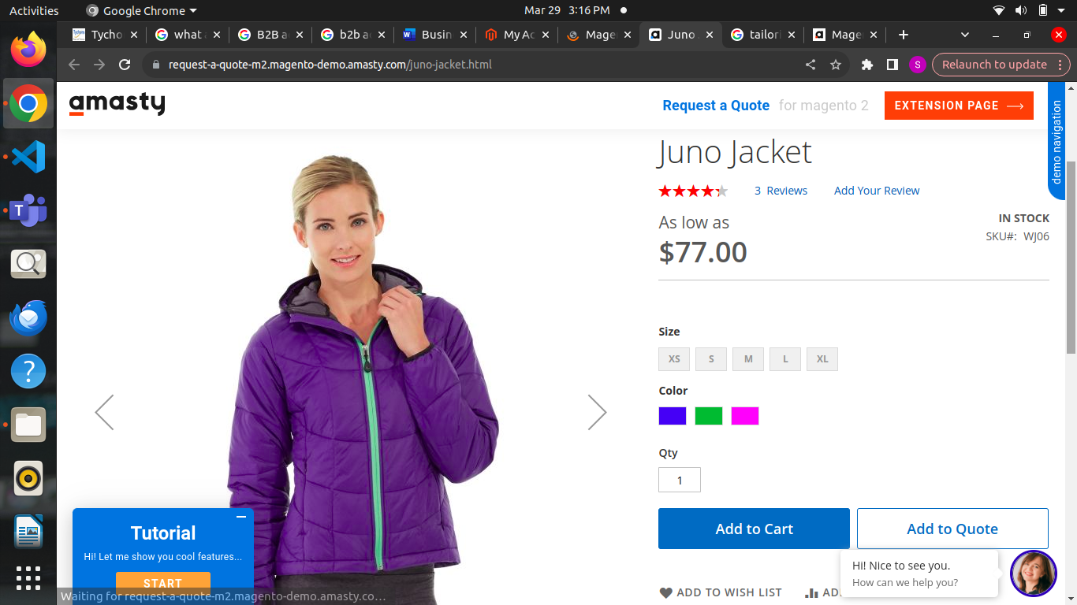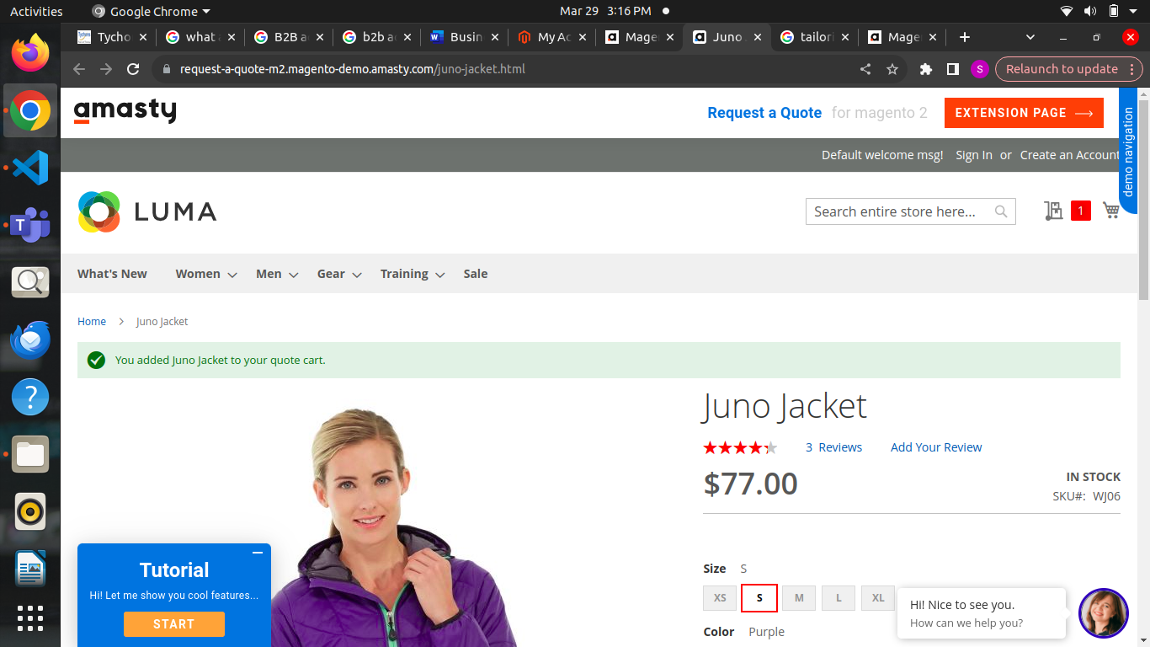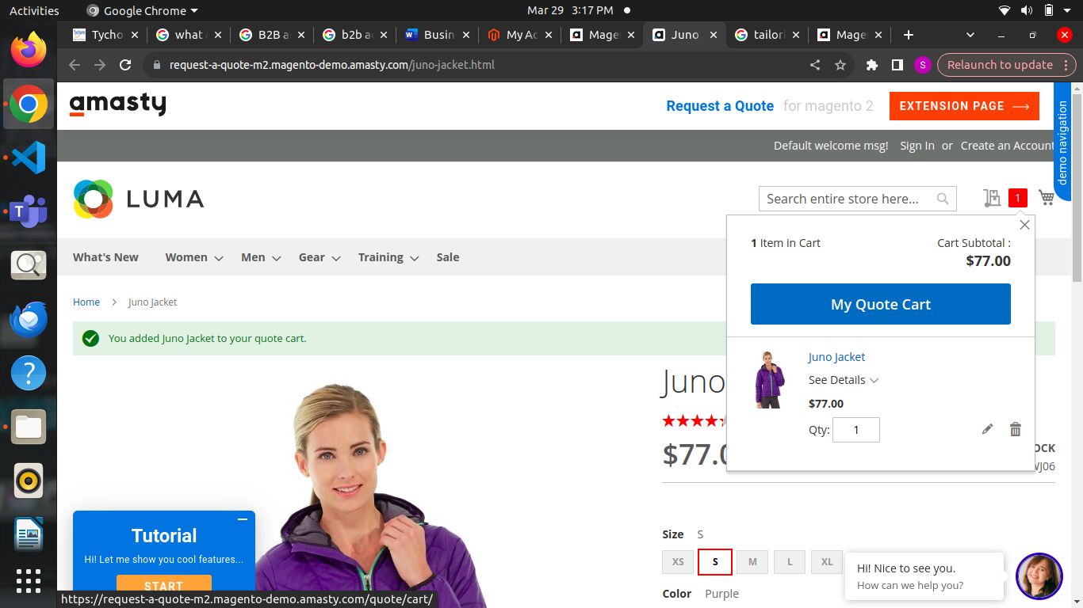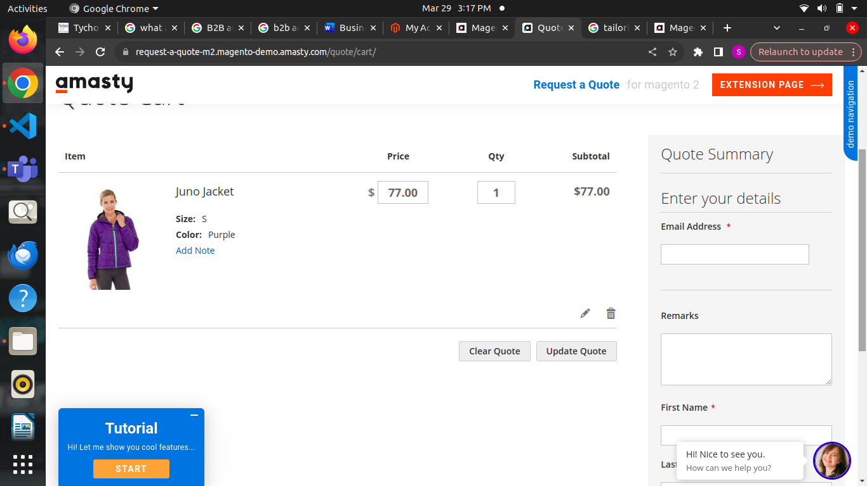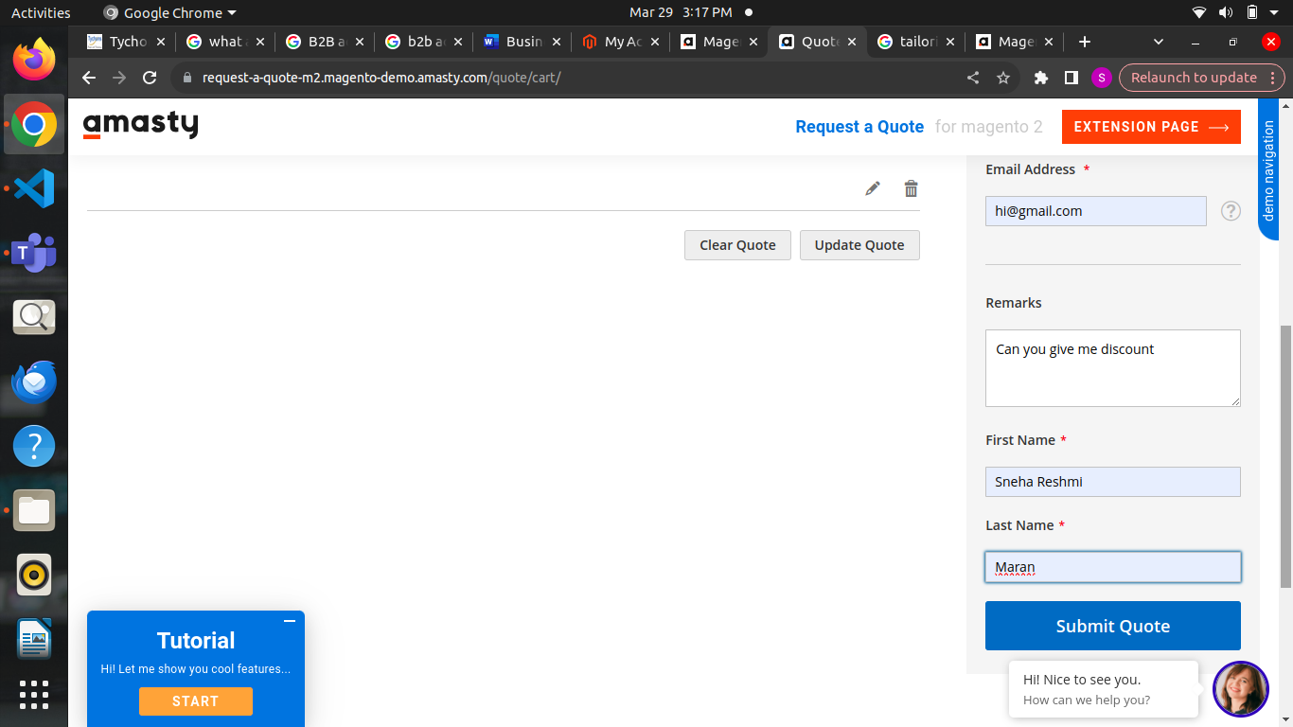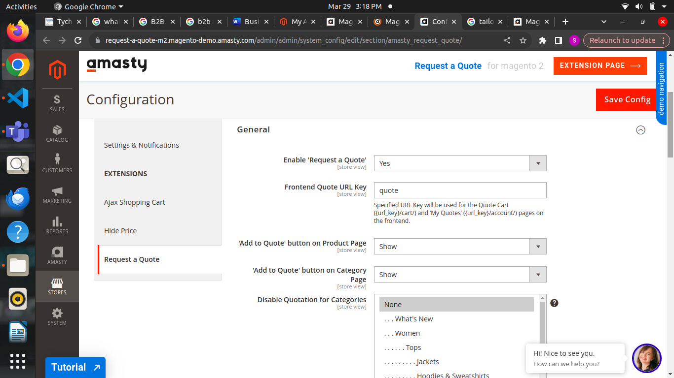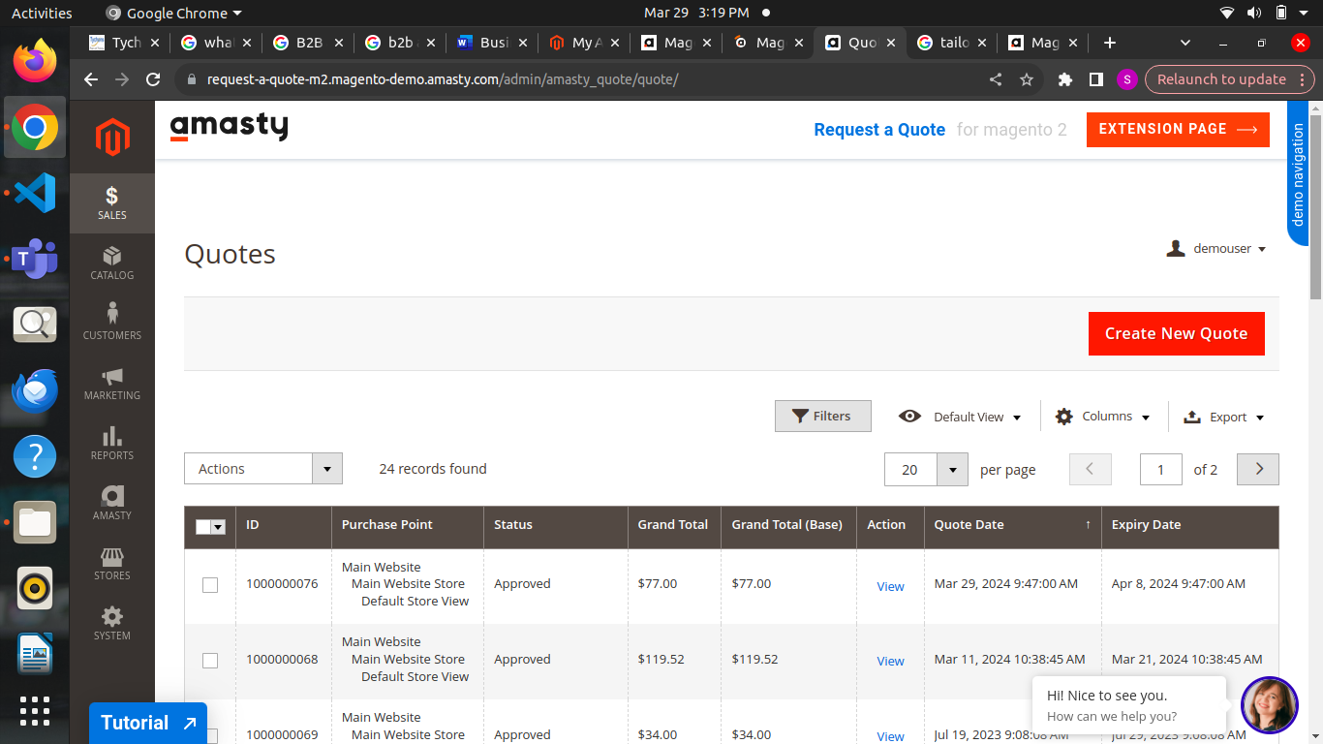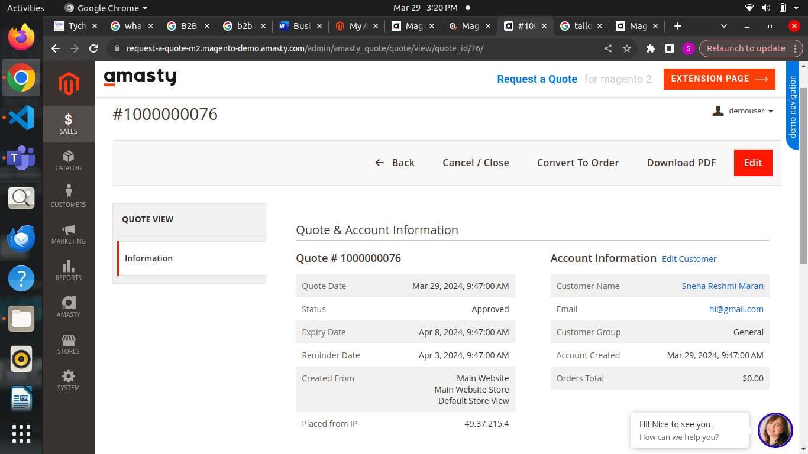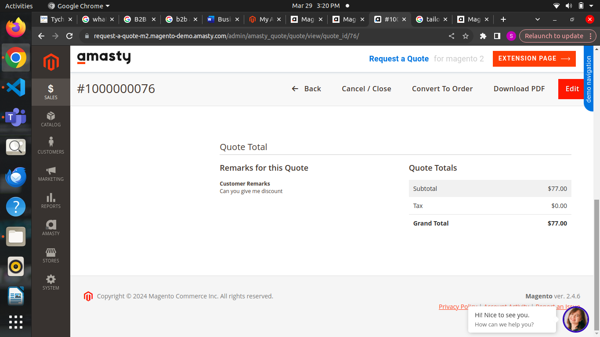

In this quote extensions and we can negotiate the customer remarks also and provide discount for the products.

**Advanced catalog management in B2b Magento 2:**

**Catalog management in b2b Magento 2**

* B2B advanced catalog management in Magento 2 is a feature that helps businesses organize and customize their product listings for their B2B customers.
* It allows them to create different customize with specific products and prices tailored to different groups of buyers.

**Purpose:**

* The purpose of B2B advanced catalog management in Magento 2 is to make it easier for businesses to sell to other businesses.
* By organizing products into specialized catalogs, companies can offer more targeted and personalized shopping experiences to their B2B customers, which can lead to increased sales and customer satisfaction.

**Usage:**

* Businesses use B2B advanced catalog management in Magento 2 to create custom catalogs for different types of customers, set specific prices for each group, and manage product visibility based on customer segments.
* It helps them provide their product offerings and pricing structures to better meet the needs of their B2B clients.

**Benefits:**

* The benefits of B2B advanced catalog management in Magento 2 include improved customer targeting and personalization, increased sales through customized product offerings, better organization and management of product listings, and enhanced competitiveness by providing a tailored shopping experience.

**Disadvantage:**

* It may require additional time and effort to set up and maintain multiple catalogs and pricing structures, especially for businesses with large product inventories.

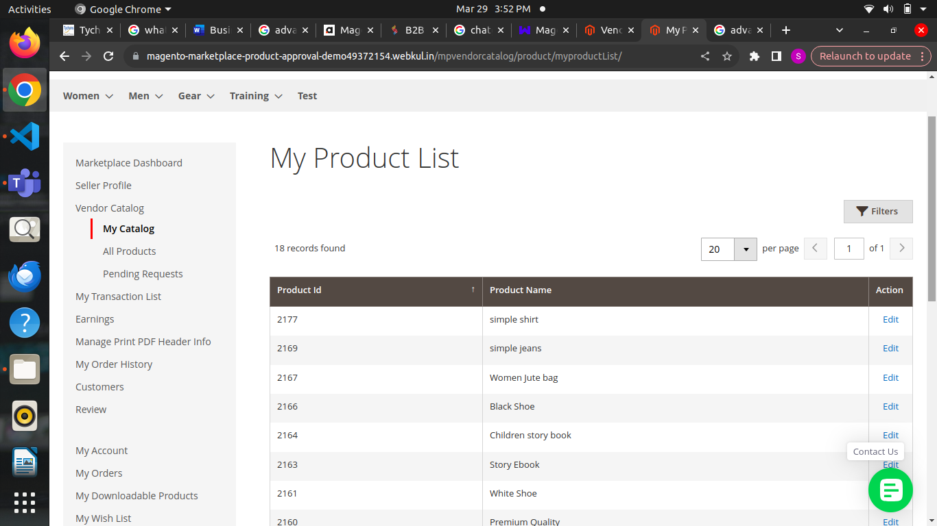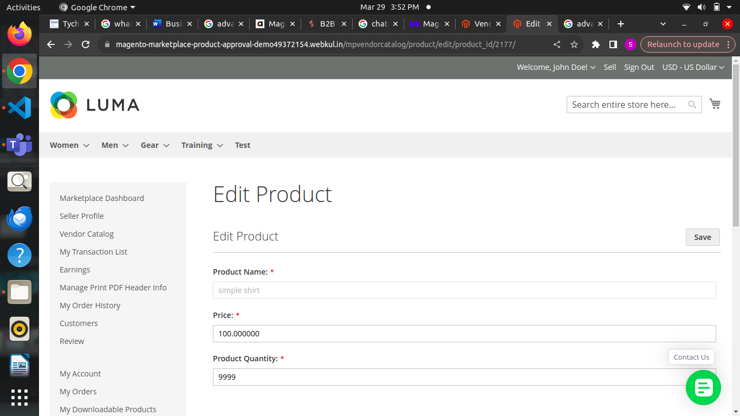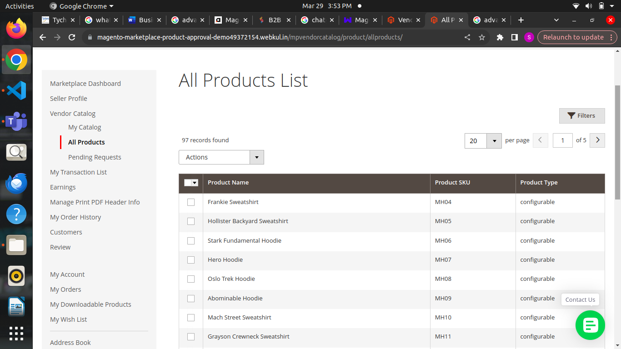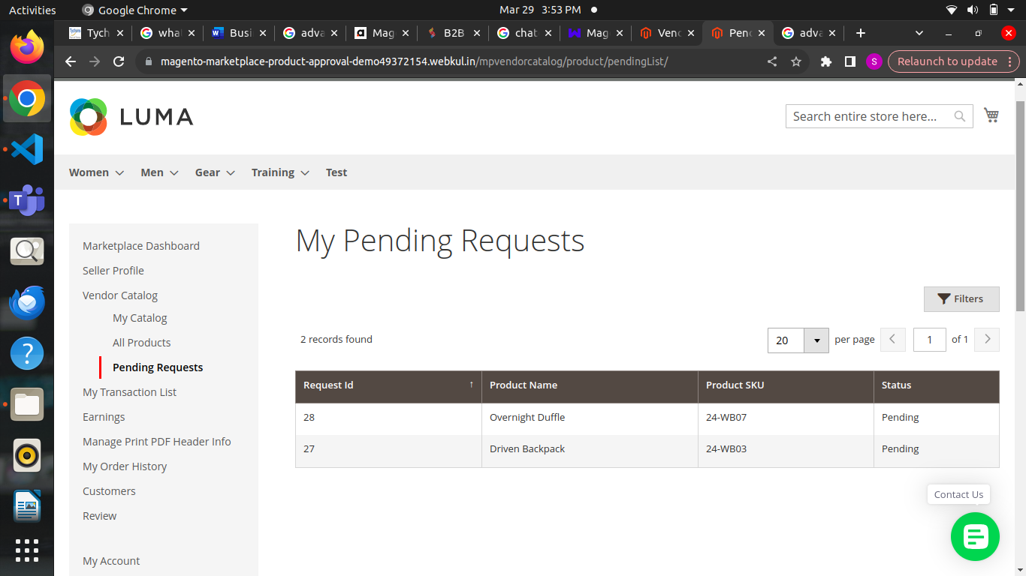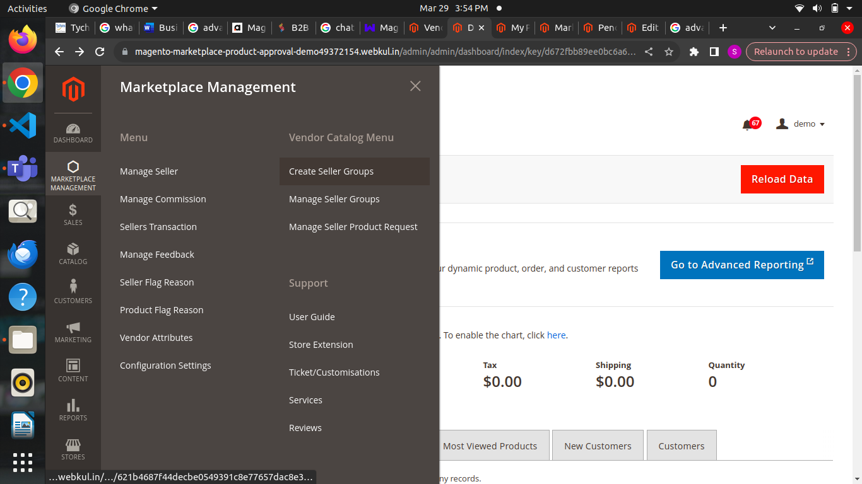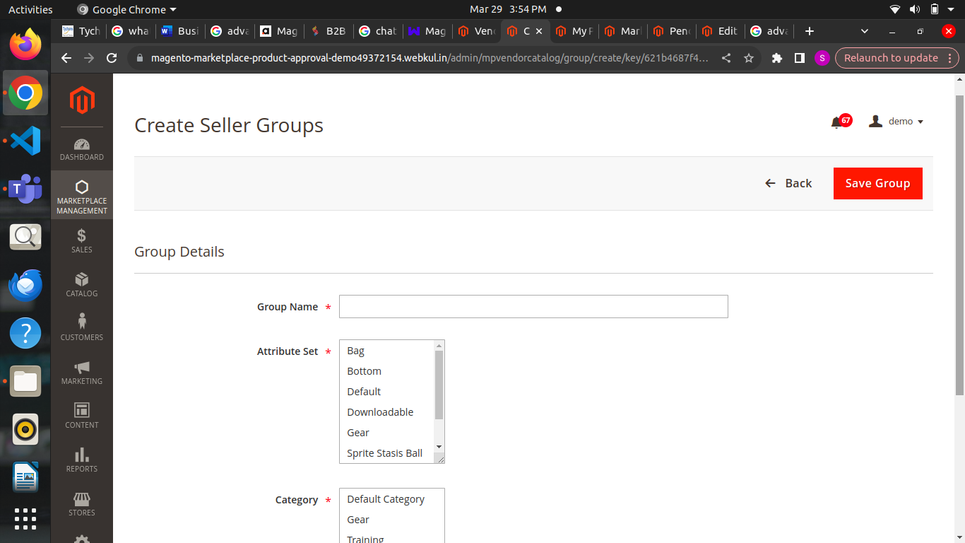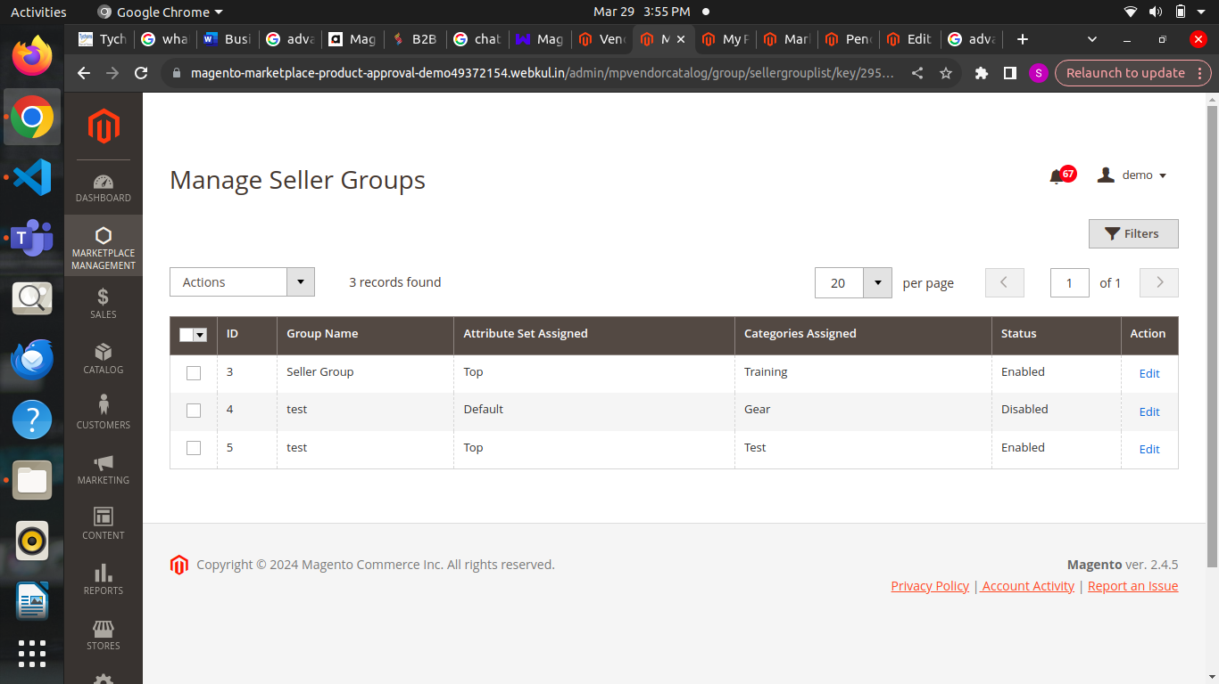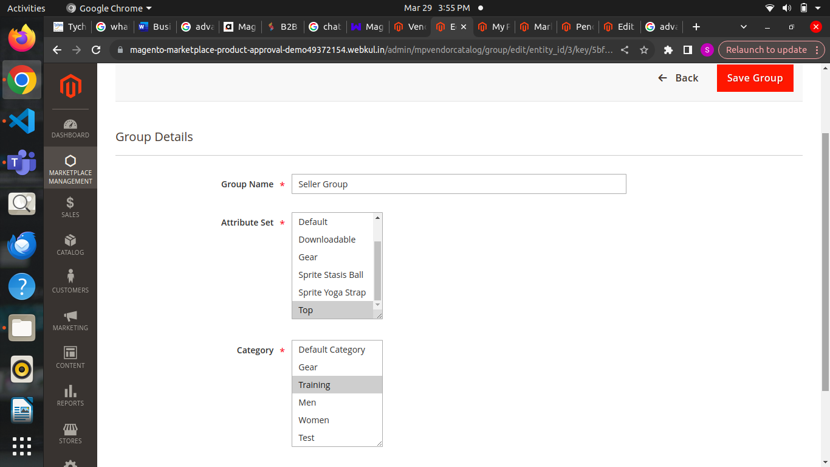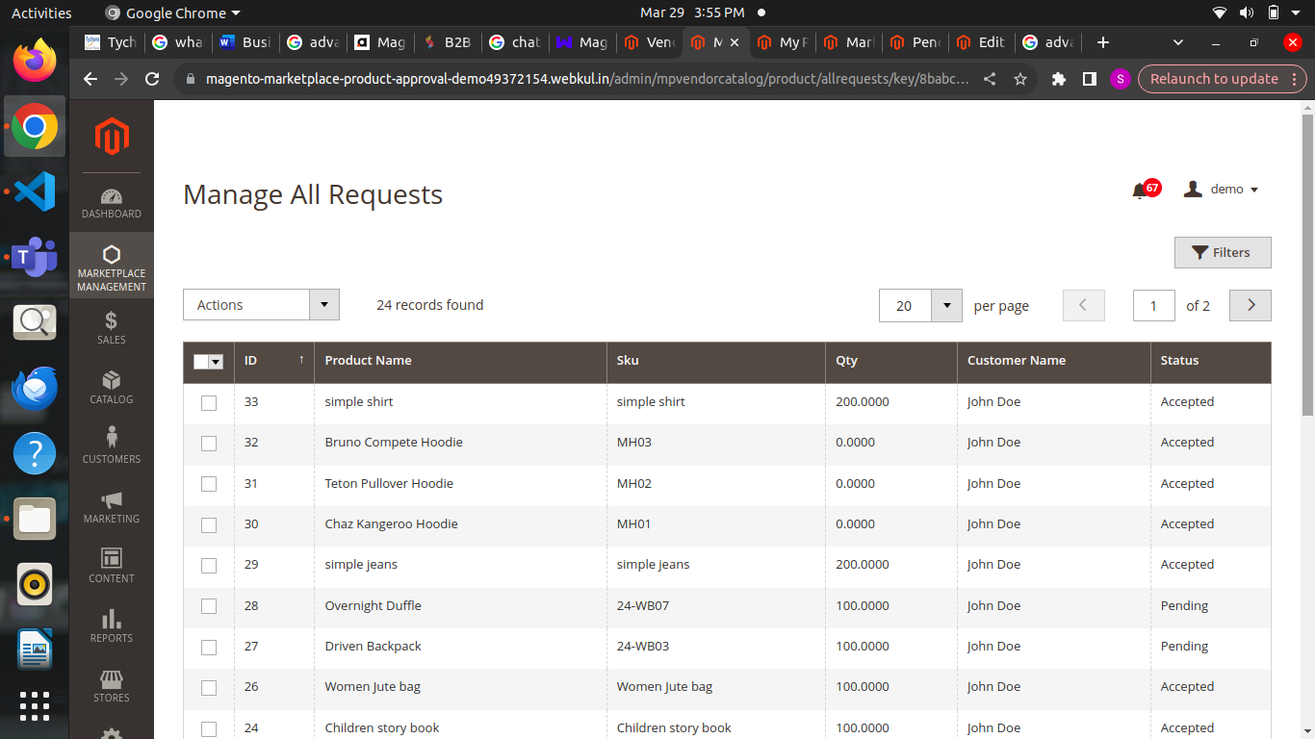

**Customizable checkout workflow in b2b**

**Customizable checkout**

* B2B customizable checkout workflow in Magento 2 is a feature that allows businesses to customize the steps and options in the checkout process specifically for their B2B customers.
* It enables customization of checkout fields, payment methods, and shipping options to suit the unique needs of B2B transactions.

**Purpose**

* The purpose of B2B customizable checkout workflow in Magento 2 is to simplify and easy the purchasing process for B2B customers.
* By customizing the checkout flow, businesses can remove unnecessary steps, offer preferred payment and shipping methods, and provide a more efficient and personalized checkout experience.

**Usage:**

* The usage of B2B customizable checkout workflow in Magento 2 involves configuring the checkout process to align with the preferences and requirements of B2B customers.
* This includes customizing checkout fields, selecting appropriate payment and shipping options, and optimizing the flow to minimize friction and enhance usability.

**Benefits:**

* The benefits of B2B customizable checkout workflow in Magento 2 include improved efficiency and convenience for B2B customers, increased conversion rates by removing obstacles in the checkout process, better alignment with business-specific needs and preferences, and enhanced customer satisfaction leading to repeat business.

**Disadvantages:**

* Customization may require technical expertise or additional development efforts, leading to increased implementation costs.
* Over-customization could also result in a complex checkout process that confuses or frustrates customers